Calcium Analyzer User Guide

Version 1.0

Laurent Mackay, Nicholas Mikolajewicz, Svetlana V. Komarova, Anmar Khadra

**Contents**

Introduction 3

Scope of Guide 3

Prerequisites 3

Citation 3

Contact Us 3

Usage 4

MATLAB Tips 9

Useful MATLAB Tips 9

MATLAB Resources 9

# Introduction

Calcium Analyzer is an algorithm for systematic characterization of calcium recordings in cells. It uses a graphical interface, allowing researchers with minimal computation background to characterize their calcium data. Data is imported directly from spreadsheet into MATLAB where the characterization is conducted.

## Scope of Guide

This user guide is intended as a guide on how to use Calcium Analyzer and not as mathematical description of how calcium traces are characterized. The underlying equations and techniques are not included in this guide; They can be found described in detail in the corresponding manuscript.

## Prerequisites

Users must have MATLAB R2016b (or later) installed along with the following toolboxes with specified versions or later:

Signal Processing Toolbox v7.3

Image Processing Toolbox v9.5

Statistics and Machine Learning Toolbox v11.0

Curve Fitting Toolbox v3.5.4.

Spreadsheet formats supported by Calcium Analyzer are XLSX and XLS files. All files provided in the Calcium Analyzer installation folder must be kept in a designated directory.

## Citation

Calcium Analyzer is provided as a free computational algorithm developed in MATLAB R2016b.

To use Calcium Analyzer in publications please cite:

Mackay L., Mikolajewicz N., Komarova SV., Khadra A. *Systematic Characterization of Dynamic Parameters of Intracellular Calcium Signals*. Frontiers in Physiology, 2016. **7**(525).

## Contact Us

Please report any problems/bugs to [Laurent.Mackay@mail.mcgill.ca](mailto:Laurent.Mackay@mail.mcgill.ca) or [Nicholas.Mikolajewicz@mail.mcgill.ca](mailto:Nicholas.Mikolajewicz@mail.mcgill.ca)

# Usage

An example.xlsx file has been provided with the Calcium Analyzer download package. It has been verified to run smoothly and new users should use it to run Calcium Analyzer first to ensure everything is working as intended.

**Step 1.** **Prepare data input file.**

* Data must be prepared in spreadsheet (.xlsx or .xls)
* Data are organized in columns such that first column represents time vector (**Fig 1**., *green*) and subsequent adjacent columns represent calcium signals (**Fig 1**., *yellow*).
  + Length of time vector must equal length of calcium signal.
* Multiple independent recordings can be prepared in single sheet (**Fig 1**), and each independent recordings can have multiple calcium signals (**Fig 2**).
  + Independent recordings organized in common sheet must be separated by blank column (**Fig 1**)
  + First row of each sheet must be left blank (**Fig 1, 2**)

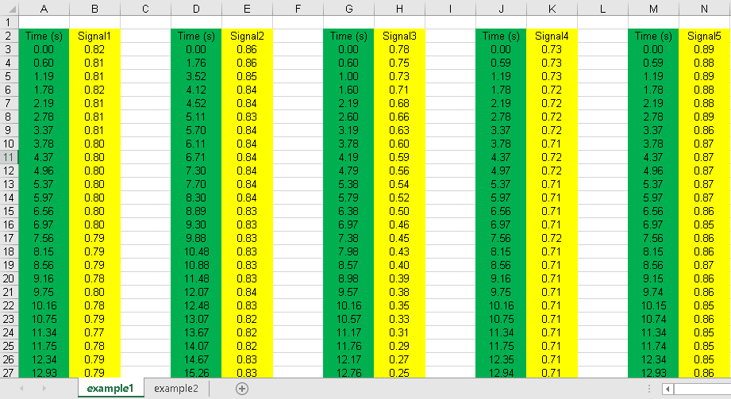

**Figure 1**. Example 1: data preparation.

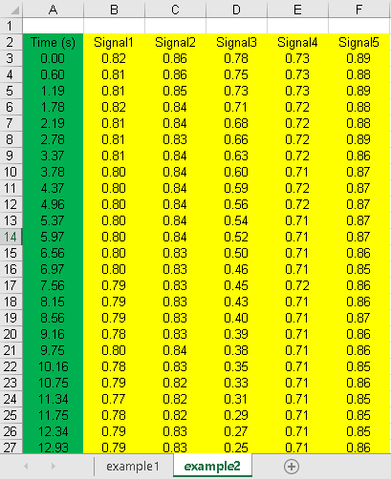

**Figure 2**. Example 2: data preparation.

**Step 2.** **Run Calcium Analyzer**

* Open the ‘MAIN.m’ file in MATLAB and press ‘RUN’ (**Fig 3**). Users can navigate through available characterization options using the provided graphical interface (**Fig 4**)
  + Calcium Analyzer performance can be visually evaluated using figures generated throughout the parameter characterization. To plot these, specify “plot”, and to save in .PNG format, specify “Save”.
  + All Calcium Analyzer MATLAB files along with input spreadsheet must be in a designated directory (**Fig 5**)
* Once input data has been specified, press “Characterize Results” and the analysis will proceed.
  + In general, it takes 1-2 seconds to analyze a single calcium signal. A complete calcium signaling experiment typically takes 5-20 minutes to analyze.

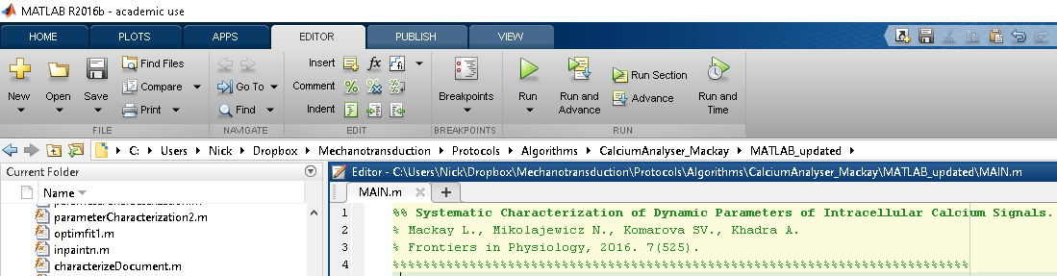

**Figure 3**. Running Calcium Analyzer in MATLAB. Open “Main.m” and press “Run” (*red box*).

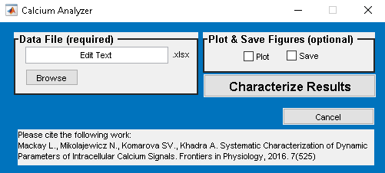

**Figure 4**. Calcium analyzer graphical interface.

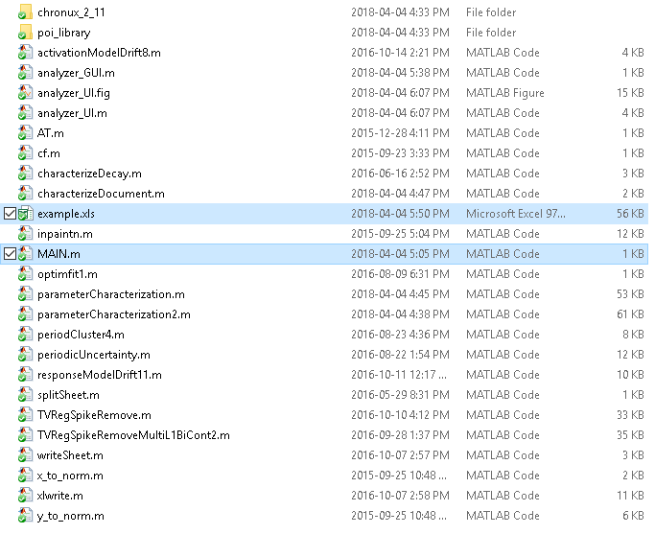

**Figure 5**. All Calcium Analyzer files and data spreadsheet input files must be stored in same directory. Highlighted is *MAIN.m* used to initiate Calcium Analyzer, and *example.xls* used as an example of a typical input data spreadsheet.

**Step 3.** **Calcium Analyzer Output**

* Once Calcium Analyzer finished running, a prompt will be presented to the user.
* Calcium Analyzer exports results into a new spreadsheet in the same directory as the data input file (**Fig 6**).
  + Results spreadsheet will have same name as input data, followed by “parameterCharacterization” and a time stamp.
* The organization of the results spreadsheet will be consistent with that of the input data (**Fig 7**).
* For a complete list and description of the parameters that are characterized, refer to the corresponding manuscript.

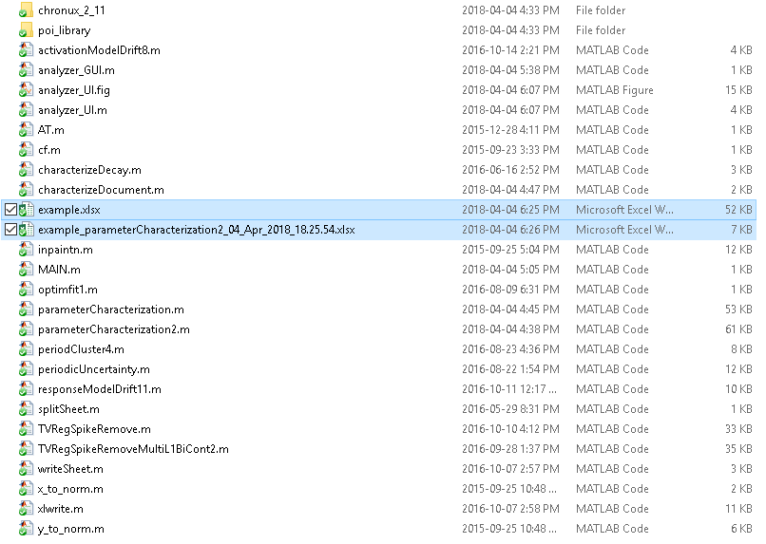

**Figure 6**. Exported results will be saved in same directory as input data (highlighted).

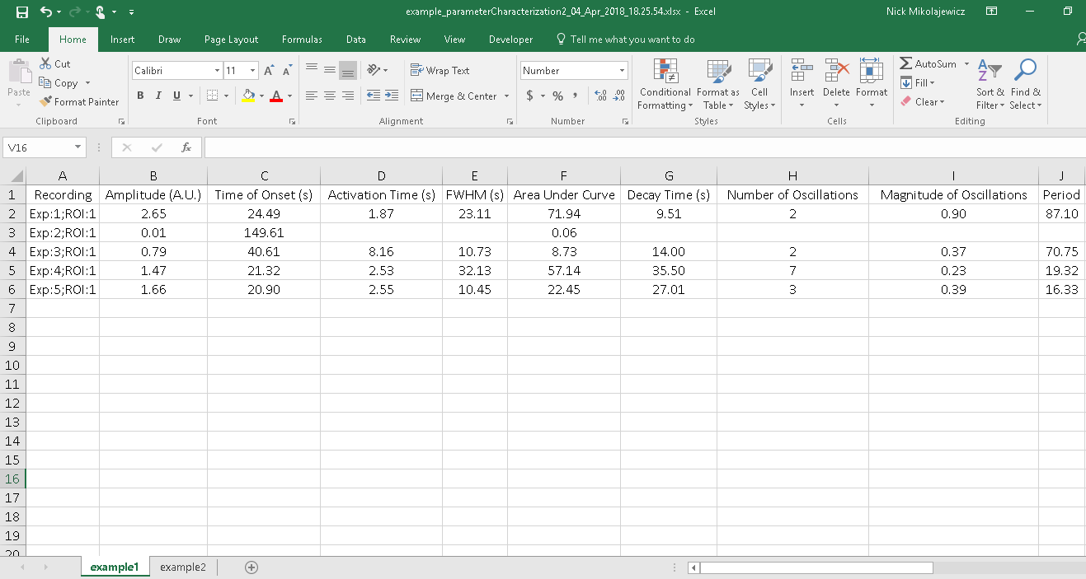

**Figure 7.** Results spreadsheet. Parameters are organized by column, and each calcium signal is organized by rows. The Recording labels indicate which recording the signal came from (Experiment; Exp), and which signal (or region of interest; ROI) was analyzed.

# MATLAB Tips

## Useful MATLAB Tips

Here we provide a selection of MATLAB operation-related tips that may come in handy while using MetaLab:

**When initiating Calcium Analyzer and presented with this dialog window…**

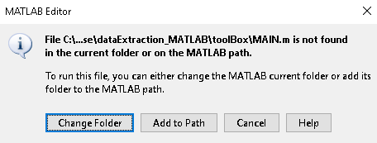

This dialog will be presented if Calcium Analyzer is not in MATLAB’s current folder. Simply press ‘Change Folder’ and the MATLAB will automatically redirect the current folder to where Calcium Analyzer files are found.

**To terminate Calcium Analyzer while it is running…**

Press ‘Ctrl+C’ on keyboard while MATLAB window is open and running

**To close all figures…**

enter following into command line

>> close all

Prior to entering command through command line, no scripts can be running in background.

**To clear variables from workspace…**

enter following into command line

>> clear all

## MATLAB Resources

For those interested in learning more about MATLAB, free resources are available online:

1. **MathWorks MATLAB documentation**: Detailed documentations MATLAB. <https://www.mathworks.com/help/matlab/>
2. **Tutorials point MATLAB tutorial**: MATLAB tutorial targeted towards beginners with little prior knowledge.

<https://www.tutorialspoint.com/matlab/>

1. **University of Michigan MATLAB Quick MATLAB Tutorial**: Quick start guide with examples and further resources

<http://web.eecs.umich.edu/~aey/eecs451/matlab.pdf>

Credit: Gowtham Bellala